http://frederic-wou.net/sonarqube-installation-on-centos-7-2/

1. cd /tmp



2. curl -O https://download.postgresql.org/pub/repos/yum/9.5/redhat/rhel-7-x86_64/pgdg-centos95-9.5-2.noarch.rpm

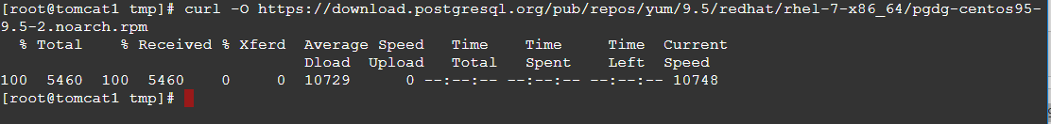

3. file pgdg-centos95-9.5-2.noarch.rpm



4. rpm -ivh pgdg-centos95-9.5-2.noarch.rpm

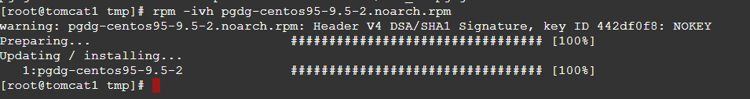

5.